**5 ideal Games**

**Big Gun**

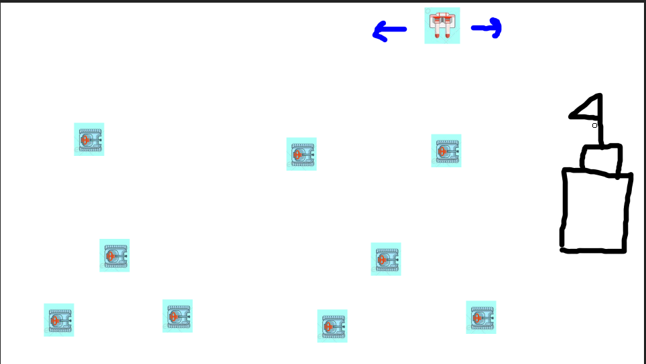

**Concept:**

The anti-tank gun has to prevent enemy tanks from entering the headquarters; the game will run on different levels day and night by changing the background. Starting from the day, the enemy tank will come as normal until night; the enemy tank will come for more than a day until the level ends.

In the game, there will be different types of enemy tanks that have a different ability. For example, a normal tank will run at a normal speed and die in one bullet, and a big tank will run at a slow speed but will die in two shootings; the small tank will run at a faster speed and die in one shooting.

During the game, there will be a special item that players can shoot to get it, and the gun can move left and right to shoot the enemy tanks or special items.

**Genre:** Headquarters defense

**Target audience:** boys, male teenagers.

**Abandon Egg**

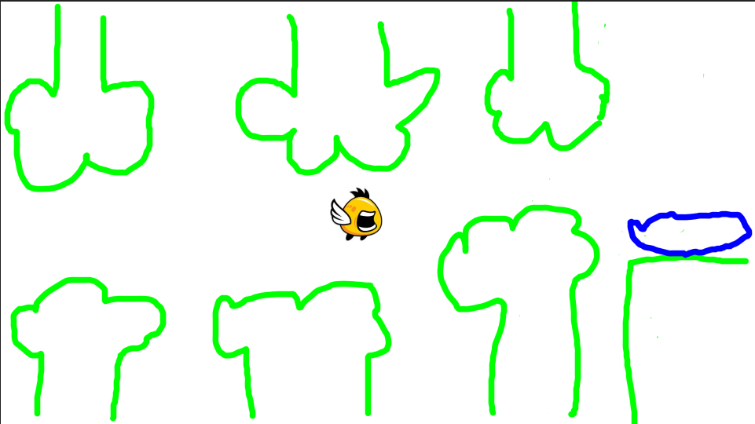

**Concept:**

During the pregnant bird's flight back to the nest, the pregnant bird laid an egg by accident, so the abandoned egg had to fly back to the nest by itself. The player has to press the space bar to make the egg higher and move forward, but the egg has to escape from the brush or any obstructed, if an egg falls or is hit with an obstacle, the game ends.

**Genre:** Casual Arcade

**Target:** children and everyone

**Rain Drop**

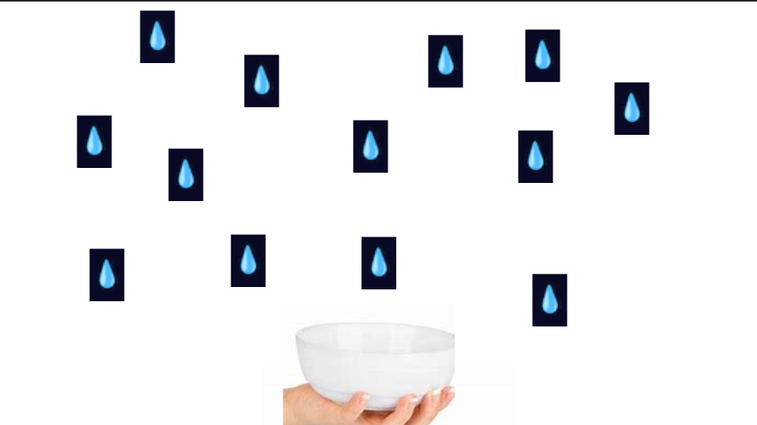

**Concept:**

The rain was dropping in the upcountry, and there was no fresh water to consume, so the people had to bring a big bowl to get the water before run out of time.

The player can move people to the left or right to get the water from the rain until the water is full in the tank before time up. If the special item is dropped, the player will get a special item, for example, a large bowl or heavy rain.

**Genre:** Casual Arcade

**Target:** children and everyone

**Balloon Hunt**

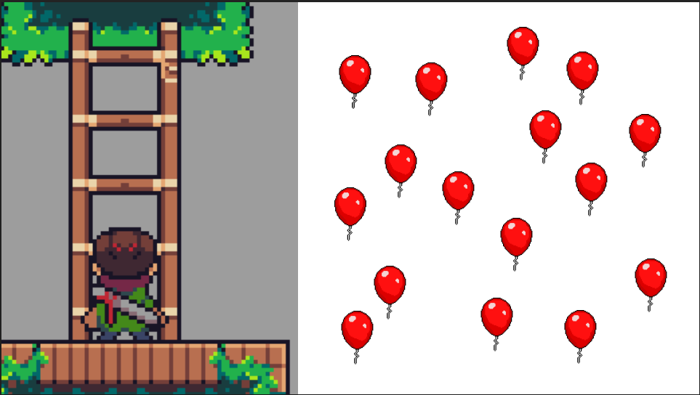

**Concept:**

They had a balloon station blowing the balloons in the balloon festival, but the old man didn't like it; he tried to pop the balloon with his dart and use his ladder to climb up higher before the balloon flew into the sky.

The player can climb the ladder up and down to throw the dart to pop the balloon before the balloon flies up to the sky and the game is over.

And the special item would fly up with the balloon, if the player hit it, player will get special item such as double dart in one shoot.

**Genre:** Casual Arcade

**Target:** children and everyone

**Boneless**

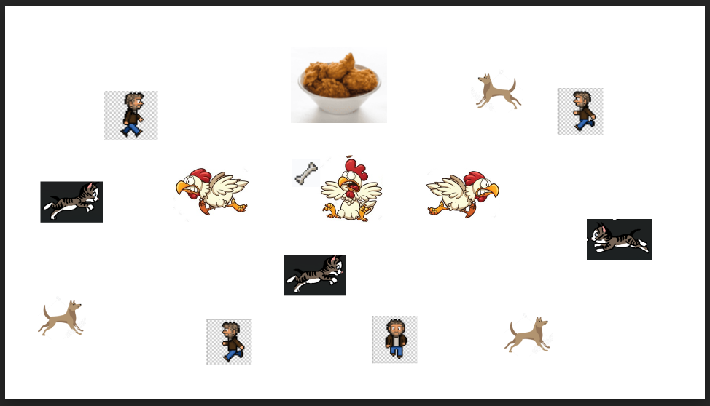

**Concept:**

This idea came up when I worked in the kitchen with the all-you-can-eat boneless chicken at the restaurant. In the game, there will be one chicken who runs away from a dog, cat, and human in the scene, and the chicken has to use its bone as a weapon to hit everything to eat it. When a dog, cat, or human touches a chicken, the chicken turns to be boneless and game over.

**Genre:** Casual Arcade

**Target:** children and everyone